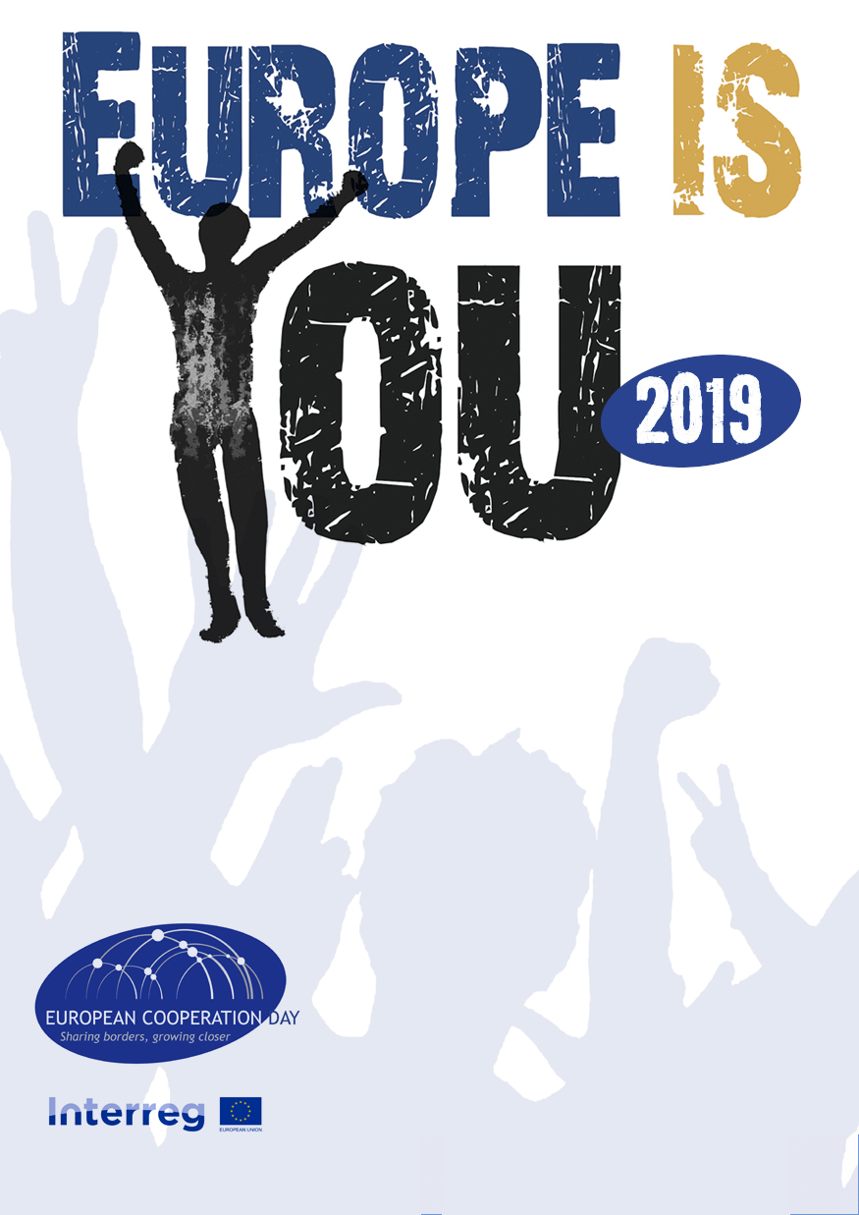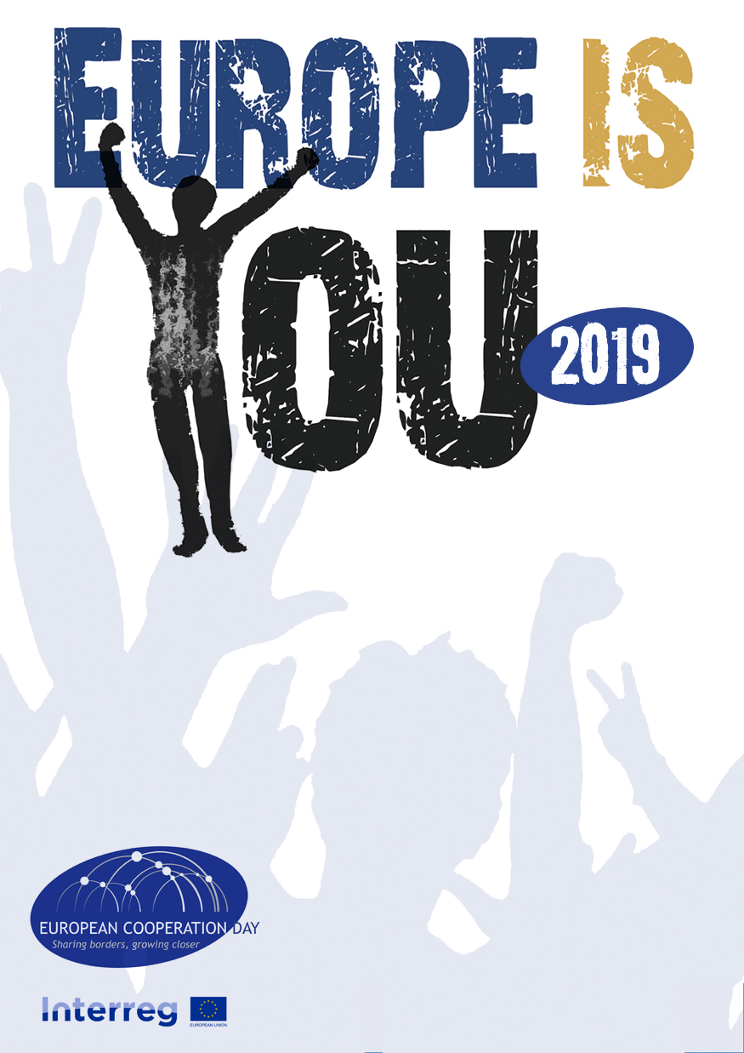

**Where: Cultural Centre, Universitat, 2**

**EUROPEAN**

**FESTIVAL**

21 September

**COOPERATION AMONG REGIONS**

Premiering “Le Gouffre”, by Vicent Le Port

Awards: best short movie and best director in “La Cabina” Festival